**Learner Compliance Promotional Campaign – Q2**

***Email / Intranet Post Template***

**Subject:** Complete Your RQI and WIN!

Hello [Hospital Name] Staff!

This quarter, you have an extra incentive to complete your RQI skills.

If you complete your RQI assignment between May 1, 2025 – May 31, 2025, you’ll be entered to win an RQI portable charger for your participation.

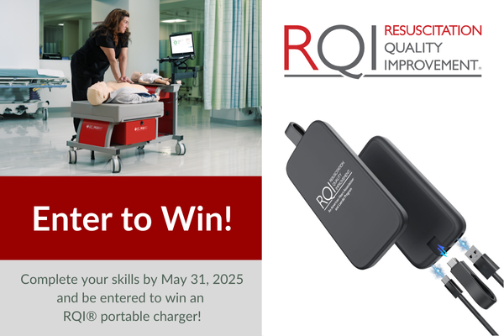

Visit the RQI station located at **[station location(s)]** to complete your assignment. Any questions, please contact **[RQI Administrator name]** by **[email]** or **[phone]**.

Let’s help save more lives together and complete our RQI assignment!

Thank you for your commitment!

[Your Name]